Objectives:
- To design a mobile application that allows persons with speech and/or hearing disabilities to communicate their intended messages to individuals without speech and/or hearing disabilities through one-way communication.
- To develop a mobile application that provides accurate sign language translations while minimizing reliance on interpreter in everyday interactions.
- To provide a mobile application that serves as an accessible Filipino Sign Language translation tool for persons with speech and/or hearing disabilities
1.4 Scope and Delimitation
The proponents developed SigLa: A Mobile Sign Language Translator Application for Persons with Speech and/or Hearing Disability that supports one-way communication that supports one-way interaction from sign language users to non-signers. The application translates Filipino Sign Language (FSL) gestures via camera and convert it into text and voice. It serves as an accessible Filipino Sign Language (FSL) translation tool for basic interaction while helping reduce heavy reliance on interpreters. The system works both online and offline. It stores information in a centralized database to support system updated and monitoring
The system has three (3) types of users: the Master Administrator, the Administrator, and the Mobile User. The master administrator has full access to the system such as managing all of the administrator account, viewing the system dashboard, managing categories for available words, managing words in the word bank, managing the model used for sign recognition, viewing the activity logs, managing reports and analytics, and managing its own account such as changing username, email address, or password. For the administrator, it can view the system dashboard, manage categories, manage words in the word bank, manage the gesture recognition model, view the activity log, manage reports and analytics, and manage its own account. Administrator accounts are managed by the master administrator only. The mobile user is the person who uses the mobile application to perform sign-to-text and text-to-speech translation. The mobile application can be used directly upon opening.
The SigLa mobile application contains four (4) modules: Main Interface, Word Bank, Translation History, and Settings. The application recognizes motion-based gestures and converts recognized gestures into text and voice output, allowing the translated text to be spoken through the device’s audio output. The system outputs individual words and the whole translation process happens in the mobile and is entirely offline. Only the downloading of the latest sign gesture recognition models and playing the demonstration video of a sign gesture requires internet connection. When the device is connected to the internet, the application automatically checks for newer sign gesture recognition model and downloads it if there is a newer version and the words in the word bank will also be synced to match the supported words of the downloaded model. Before replacing the current active model, the system performs a model integrity verification to ensure that the downloaded model is complete and not corrupted. If the download fails or the sign gesture recognition model is found to be corrupted during transfer, the previously installed model remains active to ensure that gesture recognition continues to work and the word bank will also stay the same to sync the current deployed model. After downloading the latest sign recognition model, the mobile application will prompt the mobile user to restart the application.
On the first launch of the mobile application, the app will show a short onboarding tutorial covering the main interface, gesture detection, the word bank, and how to navigate throughout the mobile application. It shows only once and can be skipped by clicking the skip button. It will appear again if the application is reinstalled or if its data is cleared. The mobile user can also view the tutorial again at any time through the settings module.
The main interface module is where the mobile user performs gesture recognition using the device camera. It detects and translates gestures automatically once the camera is active, showing the translated text in English with its Filipino translation below, and playing an audio output of the detected gesture. The mobile user can turn off the Filipino translation by pressing the Filipino translation button. After each recognized gesture, the system applies a two-second pause before accepting the next one, to avoid repeated detections. Because of this, gestures typically take about 1 to 3 seconds to detect and translate. The main interface also includes camera switch button that let the mobile user swap between front and rear camera. An emergency button that, when pressed and held for two seconds, plays an audio alert saying “Help me” to notify nearby people, with the hold requirement preventing accidental activation. The alert always plays at full volume regardless of the application current volume setting, and also shows an on-screen “Help me” banner at the same time. A retractable sidebar is also included to serve as the navigation menu, allowing mobile users to access different modules such as word bank, translation history, and settings.
The word bank displays all available categories and supported words in the mobile application. The categories include greetings, survival, numbers, letters, calendar, days, family, relationships, colors, food, drinks, ordering food, buying items, asking for prices, requesting assistance, asking for directions, and basic needs. Each category is displayed as a card. The top of the page also displays the favorites and all word cards. The all word card displays every supported word in the application, organized by category. Mobile users can search for a word using the search bar and can select a category using the dropdown list. Selecting a category displays all word under that category. Each word displays its corresponding sign video and name. When a mobile user selects a word, the application displays the word, its category, a demonstration video of the sign, and a favorite button. The demonstration video is available when the device is connected to the internet. If the device is offline, the demonstration video is unavailable and is displayed in gray. Mobile users can add or remove a word from the Favorites list by selecting the favorite button. Favorite words can be viewed by selecting the Favorites card. Favorite words are stored only on the current device. They are removed if the application is reinstalled or used on a different device. If an administrator deletes a word that is marked as a favorite, the word is automatically removed from the favorites list during the next synchronization. The word bank also includes a retractable sidebar for navigation.
The translation history module shows a record of gestures recognized in past sessions. Each entry shows the translated word, its confidence percentage, and the time it was detected, grouped by date with the most recent on top. History is saved on the device and stores up to 200 entries. As new entries are added, the oldest ones are automatically removed. Mobile users can delete individual history entries by swiping or tapping the delete button. It can also delete all history at once. Before all entries are deleted, the application displays a confirmation message asking whether they want to delete all history. If a word is later deleted from the system by an administrator, its existing history entries stay on the device, since history is stored independently of the current word database. History is cleared on reinstall or device switch. A retractable sidebar is also included to serve as the navigation menu, allowing mobile users to access different modules such as main interface, word bank, and settings.
The settings module allows the mobile users to customize the mobile application, the mobile users can adjust volume, change the voice type to male or female, and change between light mode or dark mode. Audio output is always in English, matching the translated text on the main interface module. A reset-to-default button restores original settings. The mobile user can replay the onboarding tutorial by clicking play tutorial button. All settings are saved on the device and are applied automatically whenever the application is opened. Reinstalling the application or using a different device restores the settings to default. A retractable sidebar is also included to serve as the navigation menu, allowing mobile users to access different modules such as main interface, word bank, and translation history.
The SigLa administrator platform is the web-based management interface and requires an internet connection. It has two (2) account types: the master administrator and administrator, each with different levels of access. Master administrator has full access to the features such as viewing the system dashboard, managing categories for available words, managing words in the word bank, managing the model used for sign recognition, viewing the activity logs, managing reports and analytics, managing all of the administrator account, and managing its own account such as changing username, email address, or password in account settings. The administrator can only access some of the system features such as viewing the system dashboard, managing categories, managing the models, viewing activity logs, managing reports and analytics and managing its own account. The master administrator account will be added manually by the developers directly to the database and will have initial username, password, and email address. While the administrator can only be added by master administrator. Once an administrator account is created, the Master Administrator gives the username and password to the assigned administrator. After logging in the administrator account for the first time, the system will require the administrator to link the email address, the system will send six-digit verification code to the linked email address. After entering the code, the administrator will be required to update the initial username and password given by the master administrator. Once the setup is complete, the administrator can sign in to the system anytime using the updated login credentials.
The SigLa administrator platform contains several modules depending on the account type. For the master administrator, the platform contains eight (8) modules: Dashboard, Manage Categories, Manage Words, Manage Model, Manage Administrators, Activity Logs, Reports and Analytics, and Account Settings. For the regular administrator, the platform contains seven (7) modules: Dashboard, Manage Categories, Manage Words, Manage Model, Activity Logs, Reports and Analytics, and Account Settings.
The login page is the entry point to the platform. To log in, the master administrator or administrator enters a valid username or email and the correct password. If the password is forgotten, the administrator can click "Forgot Password?" to update the password. After clicking forgot password, a modal will be shown where the administrator can enter the account's linked email address and click the send verification code button. If the account is a newly created administrator account with no linked email address yet, the system will prompt that there is currently no linked email address to that account, and the administrator must contact the master administrator to regain access. For accounts that have a linked email address, a six-digit verification code is sent to the registered email address that can be used to reset the password. After entering the six-digit code, the administrator can create and confirm a new password. After a successful reset, the page will return to the login page.
Passwords must be at least eight (8) characters long and include at least one letter and one number. After five (5) consecutive failed login attempts, the account is temporarily locked and the administrator must wait a short cooldown period of five (5) minutes before trying again. Every five (5) consecutive failed attempts, the cooldown period will increment by five (5) minutes. These requirements apply to both master administrator and administrator accounts.
The dashboard module is the first page shown after login. It displays different information depending on the logged-in account. For the master administrator account, the dashboard displays five (5) cards showing the total number of registered administrators, the total number of words in the system, the total number of gesture samples, the total number of categories, and the current model version. Selecting a card opens its corresponding page. Below the summary cards, a table displays each trained model version together with its corresponding accuracy. Another table displays the recent activities of the currently logged-in account, with the most recent activity shown first. Each record includes the activity type, description, and date. A retractable sidebar serves as the navigation menu and provides access to manage categories, manage words, manage model, manage administrators, activity logs, reports and analytics, and account settings. For the administrator account, the dashboard displays five (5) cards showing the account creation date, the total number of words in the system, the total number of gesture samples, the total number of categories, and the current model version. Selecting a card opens its corresponding page. Below the summary cards, a table displays each trained model version together with its corresponding accuracy. Another table displays the recent activities of the currently logged-in account, with the most recent activity shown first. Each record includes the activity type, description, and date. A retractable sidebar serves as the navigation menu and provides access to manage categories, manage words, manage model, activity logs, reports and analytics, and account settings.
The manage administrator module is exclusive only for the master administrator. It shows four (4) card summary at the top which includes total number of administrators registered, total number of active administrators, total number of deactivated administrators, and total number of deleted administrators. Below, it includes a table for the list of all the administrators with columns id, username, masked email address, status, date registered, and action buttons such as edit, deactivate/reactivate, and delete. When the edit button is clicked, a modal is displayed for updating the administrator account. The master administrator can update the administrator's username, password, and other account information. The master administrator can also deactivate or reactivate the administrator account. All changes are automatically recorded and reflected in the activity logs module. It also has table that includes a filter button at the top which includes all users, deactivated users, and deleted users. The manage administrator module also include create administrator button. After clicking it, a modal will be shown for creating an administrator account that shows textbox input for username, password, and confirm password. The modal also includes create and cancel button. After clicking the create button, a confirmation dialog will be shown before finally creating the administrator account. The created administrator account can now be logged in by another person and will be required to link a valid email address if logged in for the first time. A retractable sidebar is also included to serve as the navigation menu, allowing to access different modules for master administrator. It includes: dashboard, manage categories, manage words, manage model, activity logs, reports and analytics, and account settings.
The manage categories module can be accessed by both the master administrator and administrator. It includes a table where all of the categories will be shown and it has columns for category name, description, number of words for that category, and action buttons such as edit and delete button. When the edit button is clicked, a modal will pop up that includes two textboxes to edit the category name and description. The modal also includes save button and cancel button. The manage categories module also includes add category button. When add category button is clicked a modal will pop up that includes two textboxes for category name and description. The modal also includes create button and cancel button. The manage categories module would also have initial category records such as greetings, survival, numbers, letters, calendar, days, family, relationships, colors, food, drinks, ordering food, buying items, asking for prices, requesting assistance, asking for directions, and basic needs. A retractable sidebar is also included to serve as the navigation menu, allowing to access different modules depending on the account type.
The manage word allows the master administrator and administrator to add, edit, delete, and manage gesture samples for each word. It displays the existing words table, which consists of the word label, category, number of gesture samples, status, and action buttons. It also includes a search bar for searching specific words, a category filter for displaying words based on their category, and an add word button. To add a new word, the administrator can click the add word button and enter the word label, Filipino translation, and category. After entering all the required details, the administrator can save the word by clicking the add button or cancel by clicking the cancel button. New words are created without gesture samples. To upload gesture samples, the administrator can click the upload gesture sample clips button and upload recorded gesture videos from local storage. The administrator can process the uploaded videos by clicking the upload and extract button or cancel the upload by clicking the cancel button. The system automatically uses MediaPipe to extract hand and upper-body landmarks from each uploaded video and saves the extracted gesture data to the database. Each uploaded sample is automatically checked for a valid hand landmark structure. Samples that fail the validation are rejected and are excluded from the required total. A word requires at least twenty (20) uploaded gesture sequences before it can be activated. After uploading the required gesture samples, the administrator can generate the demonstration video for the word. To edit a word, the administrator can click the edit button and update the word label, Filipino translation, and category. The administrator can save the changes by clicking the save button or cancel by clicking the cancel button. The administrator can also delete a word by clicking the delete button. Deleting a word also removes its gesture samples and demonstration video. If two administrators edit the same word or category at the same time, the changes saved last are applied by the system. A retractable sidebar serves as the navigation menu and provides access to different modules based on the account type.
The manage model module allows the master administrator and administrator to train, test, deploy, revert, and delete gesture recognition models. It displays three (3) summary cards showing the total number of model versions, the total number of deployed models, and the total number of inactive models. Below the summary cards, it displays the information of the currently deployed model, including the version number, accuracy, number of classes, and deployment date. It also displays the existing model versions table, which consists of the version number, status, accuracy, trained by, trained at, and action buttons. The available action buttons depend on the model status. Newly trained models include the test, deploy, and delete buttons, while previously deployed models include the revert and delete buttons. The module also includes a train new model button. To train a new model, the administrator can click the train new model button and enter the version number and optional notes. The version number accepts only letters, numbers, dots, dashes, and underscores. After entering the required information, the administrator can start the training by clicking the start training button or cancel by clicking the cancel button. The system trains the model using the uploaded gesture data. Only one training session can run at a time. While training is in progress, the start training button is disabled until the current training session is complete. If the training process fails, the model version is marked as failed in the model list, and the administrator who started the training is notified. The currently deployed model continues to operate during the training process. To evaluate a newly trained model, the administrator can click the test button to check its accuracy before deployment. If the model meets the required performance, the administrator can activate it by clicking the deploy button. If a deployed model performs poorly or encounters issues, the administrator can restore a previously deployed version by clicking the revert button. After reverting to a previous model, the words in the manage words module are synchronized with the restored model. All trained model versions are stored in the system and can be reverted to at any time. The administrator can also delete a model version by clicking the delete button. At least one deployed model must always remain active in the system. A retractable sidebar serves as the navigation menu. It provides access to the modules available for the current account type.
The activity logs module can be accessed by both the master administrator and the administrator. It allows both account types to view the history of significant activities performed in the system. It displays the existing activity logs table, which consists of the user who performed the action, the action type, the affected item, a short description, and the date and time. The module also includes filters for action type, affected item, and date range. The activity logs record significant actions performed in the system, including adding, editing, deleting, or activating a word, uploading gesture samples, training, testing, deploying, or reverting a model, managing administrator accounts, and signing in. The activity logs are displayed with the most recent entries shown first. The records are read-only to preserve the audit trail and are stored permanently in the system without automatic deletion. It has a retractable sidebar provides navigation to the modules available based on the account type.
The reports and analytics module can be accessed by both the master administrator and the administrator. It allows both account types to view the summary of system growth and generate reports. It displays four (4) summary cards showing the total number of words, the total number of gesture samples, the total number of categories, and the current model accuracy. Below the summary cards, it displays a line chart showing the growth of words and gesture samples over time. The chart can be filtered by week, month, or year. It also displays the model version history table, which consists of the version number, accuracy, and date created. The module also includes a generate report button. To generate a report, the administrator can click the generate report button and select the data to include in the report, such as word statistics, gesture sample counts, and model accuracy. The administrator can also select the time period using the dropdown list. After selecting the required information, the administrator can generate the report by clicking the generate button or cancel by clicking the cancel button. The system exports the selected information as a PDF report. It also has a retractable sidebar.
The account settings module can be accessed by both the master administrator and the administrator. It allows both account types to view and update their account information. It displays the account username, masked email address, and account type. The module also includes an edit profile button and a change password button. To update the username, the administrator can click the edit profile button and enter the new username. The administrator can save the changes by clicking the save button or cancel by clicking the cancel button. To add an email address, the administrator can click the add email address button, enter the email address, and click the send verification code button to receive a six-digit verification code. After entering the verification code, the email address is linked to the account. To change the email address, the administrator can click the change email button, enter the new email address, and complete the same verification process using the six-digit verification code before the new email address is saved. The administrator can also cancel the process by clicking the cancel button. To change the password, the administrator can click the change password button and enter the six-digit verification code sent to the registered email address. After entering the verification code, the administrator can enter the new password and confirm password. The administrator can save the new password by clicking the save button or cancel by clicking the cancel button. The password must contain at least eight (8) characters, including at least one letter and one number. It has a side bar.
The system architecture consists of the SigLa mobile application, SigLa administrator platform, SigLa Backend Server, SigLa Machine Learning Component, and PostgreSQL Database. The mobile application communicates with the backend server to fetch the latest word bank content and model updates. The backend serves as the bridges between the mobile app, the administrator platform, the machine learning module, and the database. The machine learning module handles model training, testing, deployment, while the database stores administrator accounts, words, gesture samples, and model information. The system follows a client-server architecture: the mobile app handles gesture recognition locally using a downloaded TFLite model, while the backend server manages word, category, and model management, and model updates, through a REST API.
The system is developed using Kotlin for the Android mobile application, React.js for the web-based administrator platform, Node.js with Express.js for the backend server, Python for the machine learning component, and PostgreSQL as the database management system. The system also uses Supabase as the cloud platform for database hosting and storage. Development tools used include Android Studio, Visual Studio Code, Postman, and GitHub.
The proponents recognize that gesture recognition performance can be influenced by device specifications and environmental conditions, and the system is designed to adapt and perform effectively within these factors. Devices with higher hardware capabilities may enhance performance. The system aims to provide accurate translations, but occasional inaccurate translations may occur. Recognition results may also be influenced by environmental factors such as insufficient lighting, a dirty or damaged camera lens, camera obstruction, or excessive distance between the camera and the hand gesture. The system supports Filipino Sign Language (FSL) gestures, and the main interface displays translated text only in English and Filipino. SigLa produces individual words only and does not form full sentences or continuous conversational translation. The English translation exists solely to make the recognized gesture more broadly understandable, since many FSL gestures map to concepts more commonly expressed in English. The underlying gesture recognition, dataset, and translation process are based entirely on FSL. The system recognizes only sign gestures, with each mapped to a predefined word from the trained dataset. Variations in hand structure, such as incomplete or irregular fingers, may affect recognition accuracy. The system is designed to improve gesture recognition within its capabilities and to continuously support clear and effective gesture-based communication.
For optimal recognition, the recommended distance between the camera and the hand gesture should not exceed 0.5 meters. The system supports left-handed and right-handed users, and gestures that require one or both hands, for up to two hands recognized at once.
The system requires a stable internet connection with a minimum speed of 10 Mbps for features that need server communication, such as loading the latest word bank content and downloading model updates. Recommended minimum mobile specifications include a 13-megapixel camera, at least 6GB of RAM to keep the camera, landmark detection, and gesture recognition running smoothly together, and Android version 7.0 (Nougat) or higher. The SigLa Mobile Application is developed exclusively for Android and does not support iOS or any other mobile operating system.

- RESULT AND DISCUSSION
This chapter contains the project description, project structure, and project evaluation.

  - Project Description
The proponents of SigLa: A Mobile Sign Language Translator Application for Persons with Speech and/or Hearing Disabilities developed a system that aims to improve communication between persons with speech and/or hearing disabilities and individuals who do not understand Filipino Sign Language (FSL). Many individuals who use sign language experience communication barriers in everyday situations due to the limited number of people who understand FSL. SigLa provides an accessible mobile solution by translating recognized Filipino Sign Language gestures into text and voice output, allowing users to communicate through one-way interaction. The system operates both online and offline, with internet access required only for downloading the latest gesture recognition model and accessing online demonstration videos.
The system features a mobile application designed for gesture recognition using the device camera. It automatically detects supported Filipino Sign Language gestures and translates them into English text, displays the corresponding Filipino translation, and produces voice output through the device speaker. The application also includes an emergency alert feature, translation history, customizable settings, and an onboarding tutorial to help users learn the application's features and navigation. The system includes a word bank module that provides a collection of supported Filipino Sign Language words organized into categories such as greetings, survival, numbers, letters, calendar, days, family, relationships, colors, food, drinks, ordering food, buying items, asking for prices, requesting assistance, asking for directions, and basic needs. Each word contains a demonstration video, when the internet is available, to help users learn the proper sign. Users can also search for words, browse by category, and save frequently used words as favorites.
To support continuous improvement of gesture recognition, SigLa includes a web-based administrator platform with two account types: the Master Administrator and the Administrator. The master administrator has full control of the system, including managing administrator accounts, while the administrator is responsible for managing categories, words, gesture samples, gesture recognition models, activity logs, reports and analytics, and personal account settings. The platform enables the master administrator and administrators to upload gesture samples, train, test, deploy, and revert gesture recognition models to maintain accurate and reliable sign language translation.
The system uses a client-server architecture consisting of the android mobile application, a web-based administrator platform, a backend server, a machine learning component, and a PostgreSQL database. Gesture recognition is performed locally on the mobile device using a deployed TensorFlow Lite model, while the backend manages words, categories, gesture samples, administrator accounts, and model updates. This architecture allows the application to continue recognizing gestures offline while synchronizing new models and word bank updates whenever an internet connection is available.
The proponents evaluated the system's functionality, usability, and accessibility by conducting system testing and user evaluation involving both technical and non-technical participants. The evaluation assessed how effectively users could understand and operate the mobile application and administrator platform, helping identify areas for improvement while determining the system's overall quality and suitability as a Filipino Sign Language translation tool for everyday communication.
  - Project Structure
Figures 56, 57, and 58 present the Visual Table of Contents (VTOC) of the SigLa mobile application for the mobile user, master administrator, and administrator. The mobile application for the mobile user contains six (6) main menus: Home, Word Bank, Translate, Notifications, Profile, and Settings. The master administrator contains seven (7) main menus: Dashboard, Manage Words, Manage Model, Manage Administrators, Activity Logs, Reports and Analytics, and Account Settings. The administrator contains six (6) main menus: Dashboard, Manage Words, Manage Model, Activity Logs, Reports and Analytics, and Account Settings.
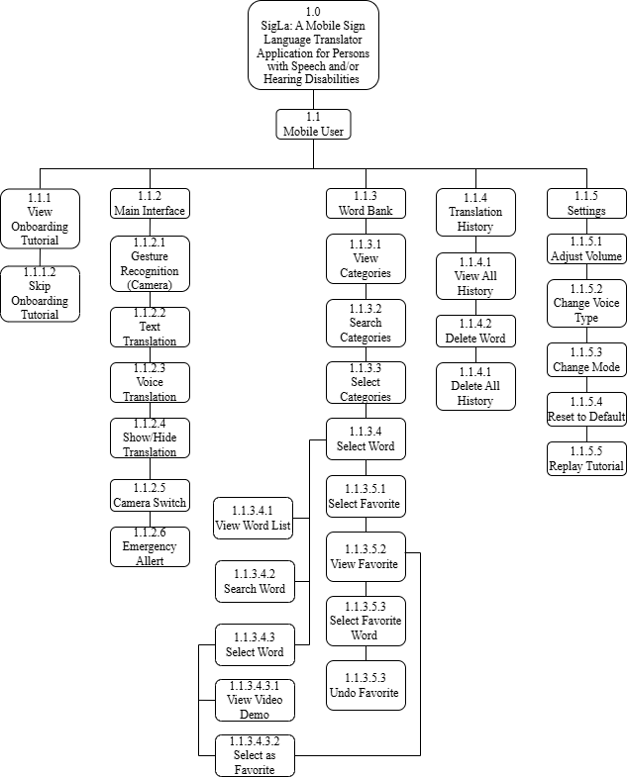
Figure 56: Visual Table of Contents for Mobile User

Figure 56 presents the Visual Table of Contents (VTOC) for the mobile user of the SigLa system. It illustrates the overall structure and navigation of the mobile application. Upon opening the application, the mobile user can first view the onboarding tutorial, with the option to skip it and proceed to the main interface. The main interface provides access to the gesture recognition camera for translating Filipino Sign Language (FSL) gestures into text and voice. It also includes features for viewing the translated text, playing the voice translation, switching the camera, and accessing the emergency alert.
The mobile user can also access the word bank, which allows browsing available categories, searching categories, selecting a category, and viewing the list of words under the selected category. After selecting a word, the user can view its demonstration video and add or remove it from the favorites list. Favorite words can be viewed and managed through the favorites section. The application also includes a translation history feature, where users can view previous translations, delete individual history records, or delete all stored history. In the settings section, the user can adjust the volume, change the voice type, switch between light and dark mode, reset the application settings to their default values, and replay the onboarding tutorial. Overall, the VTOC presents a clear and organized structure of the mobile application, allowing users to easily access the translation, word bank, history, and settings features that support basic Filipino Sign Language (FSL) communication for daily interactions.

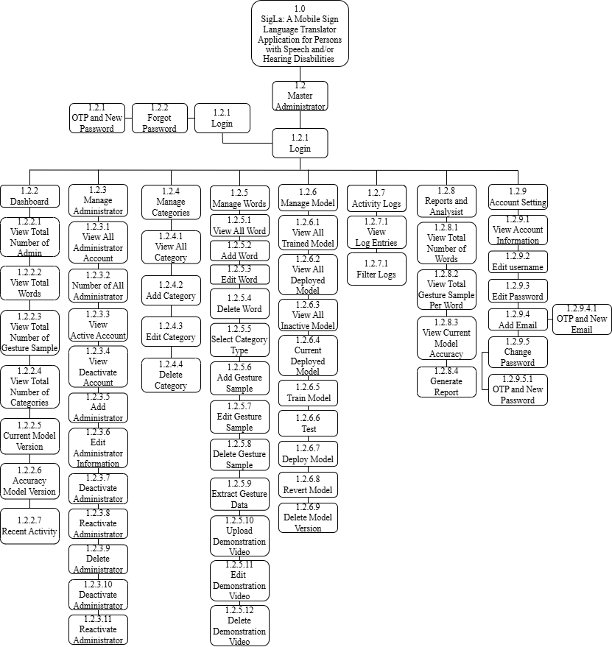
Figure 57: Visual Table of Contents for Master Administrator
Figure 57 presents the Visual Table of Contents (VTOC) for the master administrator of the SigLa system. It illustrates the overall structure and navigation of the web-based administration platform from the master administrator's perspective. At the top level, the master administrator can log in to the system, recover a forgotten password, and verify the account through a one-time password (OTP) before creating a new password. Once logged in, the main modules include Dashboard, Manage Administrators, Manage Categories, Manage Words, Manage Model, Activity Logs, Reports and Analytics, and Account Settings.
The Dashboard provides an overview of the system by displaying the total number of registered administrators, words, gesture samples, categories, the current model version, the current model accuracy, and recent account activities. The Manage Administrators module allows the master administrator to view all administrator accounts, active accounts, and deactivated accounts. It also provides functions for adding, editing, deactivating, reactivating, and deleting administrator accounts. The Manage Categories module enables the master administrator to view, add, edit, and delete word categories used in the mobile application's Word Bank.
The Manage Words module allows the master administrator to manage the system's word database by viewing, adding, editing, and deleting words. It also supports selecting word categories, uploading and managing gesture samples, extracting gesture data, and generating, updating, or deleting demonstration videos. The Manage Model module enables the master administrator to view trained, deployed, and inactive model versions, train new gesture recognition models, test model accuracy, deploy new models, revert to previous versions, and delete model versions.
The Activity Logs module records significant activities performed in the system and provides options to view and filter log entries. The Reports and Analytics module presents system statistics, including the total number of words, gesture samples, current model accuracy, and model version history. It also allows the master administrator to generate PDF reports. Lastly, the Account Settings module allows the master administrator to view account information, update the username, add or change the registered email address through OTP verification, and change the account password. Overall, the VTOC presents a clear and organised structure of the master administrator's functions, allowing complete management of administrator accounts, words, gesture recognition models, system reports, and account settings.

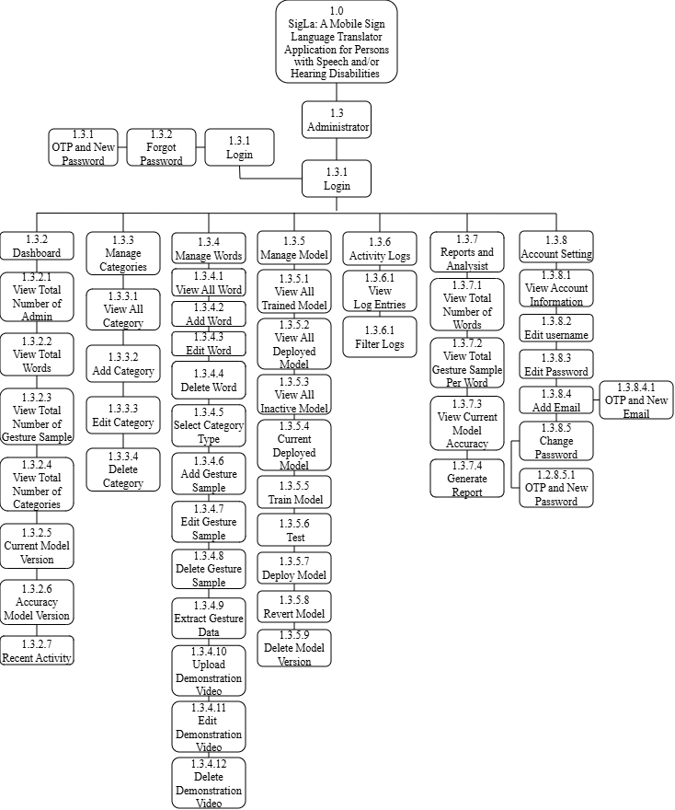
Figure 58: Visual Table of Contents for Administrator

Figure 58 presents the Visual Table of Contents (VTOC) for the administrator of the SigLa: A Mobile Sign Language Translator Application for Persons with Speech and/or Hearing Disabilities. It shows the organization and navigation of the web-based administration platform available to the administrator. Before accessing the system, the administrator can log in using the assigned account credentials. The system also provides options for password recovery through a one-time password (OTP) verification process. After a successful login, the administrator can access the Dashboard, Manage Categories, Manage Words, Manage Model, Activity Logs, Reports and Analytics, and Account Settings modules.
The Dashboard provides a summary of important system information, including the account creation date, total number of words, gesture samples, categories, the current model version, the current model accuracy, and recent account activities. Through the Manage Categories module, the administrator can organize the categories used in the mobile application's Word Bank by adding, editing, and deleting categories. The Manage Words module allows the administrator to maintain the system's word database by creating, updating, and removing words, uploading gesture samples, extracting gesture data, and managing demonstration videos. The Manage Model module supports training, testing, deploying, reverting, and deleting gesture recognition models while displaying the available model versions and their corresponding information.
The Activity Logs module enables the administrator to review and filter recorded system activities performed within the platform. The Reports and Analytics module provides charts, statistical summaries, and model performance information, and it also allows the administrator to generate PDF reports. The Account Settings module enables the administrator to update the username, add or change the registered email address through OTP verification, and change the account password. Overall, the VTOC presents a structured view of the administrator's available functions, allowing efficient management of the word database, gesture recognition models, system reports, and personal account settings.

